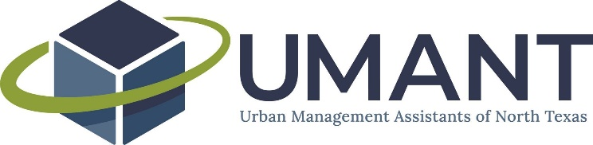

UMANT Executive Committee Agenda
February 5, 2021
2:00 PM – 3:00 PM
Virtual

Call-in information
Dial in: 720-835-5352
PIN: 95148
Join the call via UberConference: uberconference.com/umantexec

- Approval of January 8, 2021 minutes

- Budget review

- NTCMA Board Meeting Update – Laurie

- Discussion on ways to use digital content

- Committee Updates
  - Networking & Mentorship
    - Mentorship program
    - Virtual happy hour summary
  - Professional Development
    - Professional Development lunch update
  - Membership & Partnerships
    - Survey
  - Communications
    - Blog/newsletter update
  - Special Events
    - Wine & Dine

- General meeting items

- Future agenda item requests
  - Bylaws update for 2nd round of scholarships
  - Budget adoption
Next Meeting: Friday, March 5 at 2PM

Notes:

