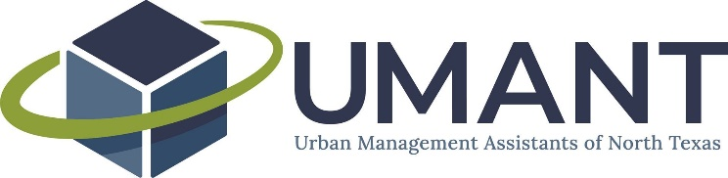

UMANT Executive Committee Agenda
April 2, 2021
2:00 PM – 3:00 PM
Virtual

Call-in information
Dial in: 720-835-5352
PIN: 95148

Join the call via UberConference: uberconference.com/umantexec

- Approval of March 5, 2021 minutes

- Budget update

- TCMA Assistants’ Reception

- Committee Updates
  - Networking & Mentorship
    - Mentorship program
  - Professional Development
  - Membership & Partnerships
    - Survey
  - Communications
  - Special Events
    - One Day Conference

- General meeting items

- Future agenda item requests

Next Meeting: Friday, May 7, 2021 at 2PM

Notes:

